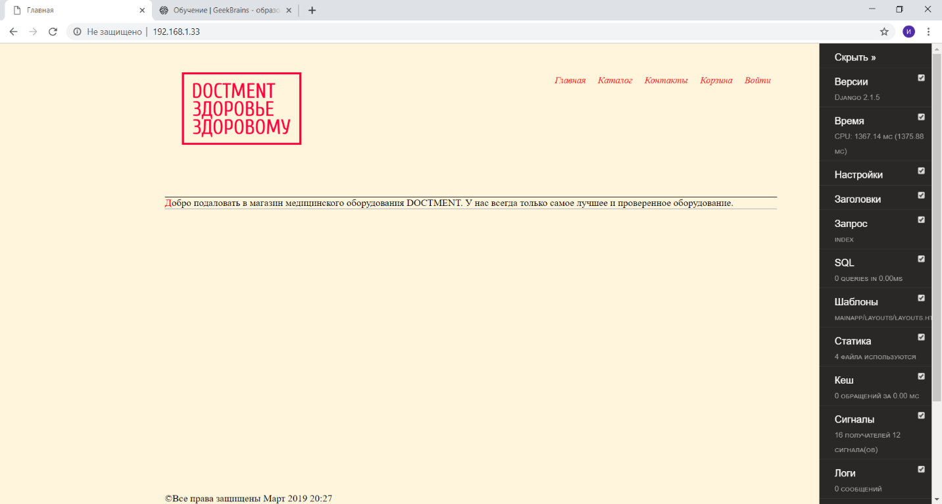

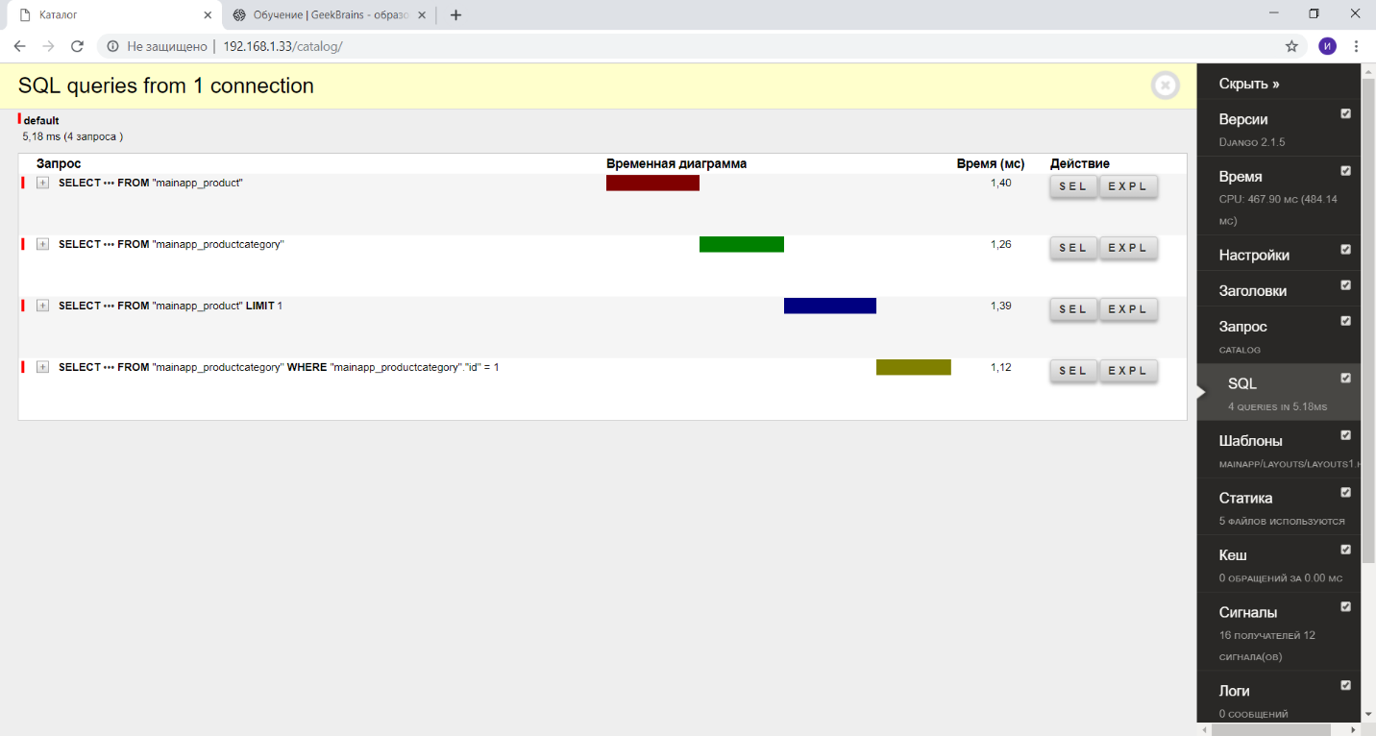

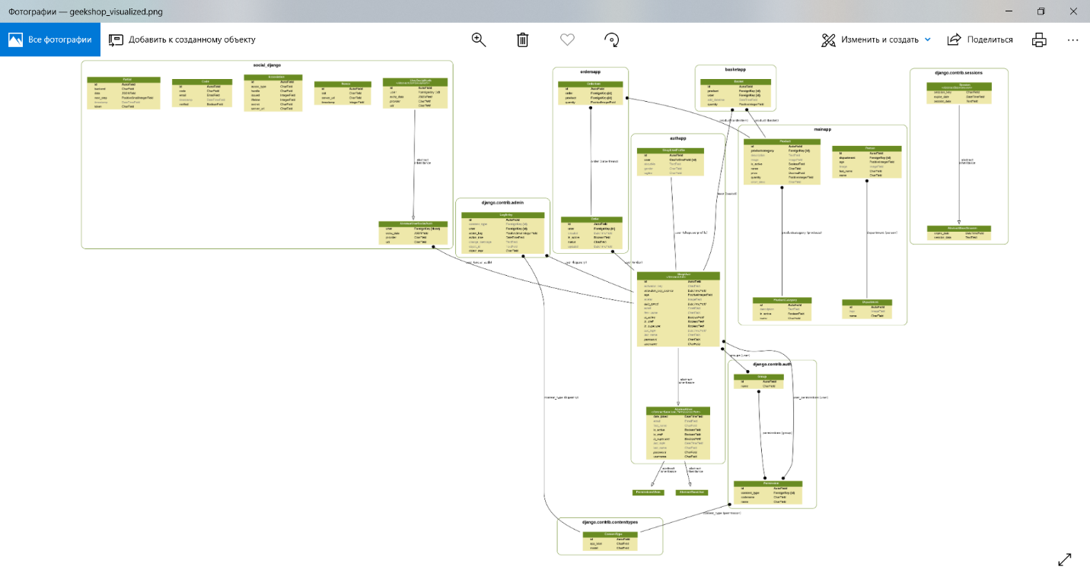

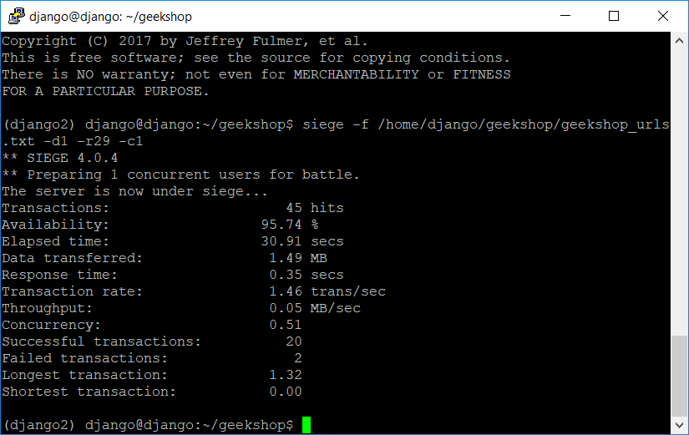

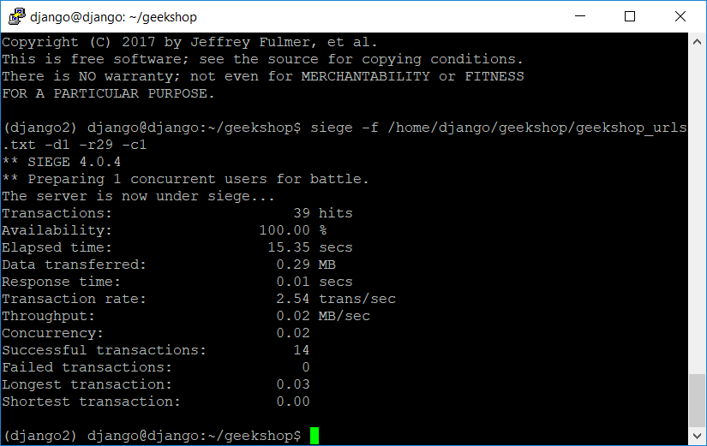

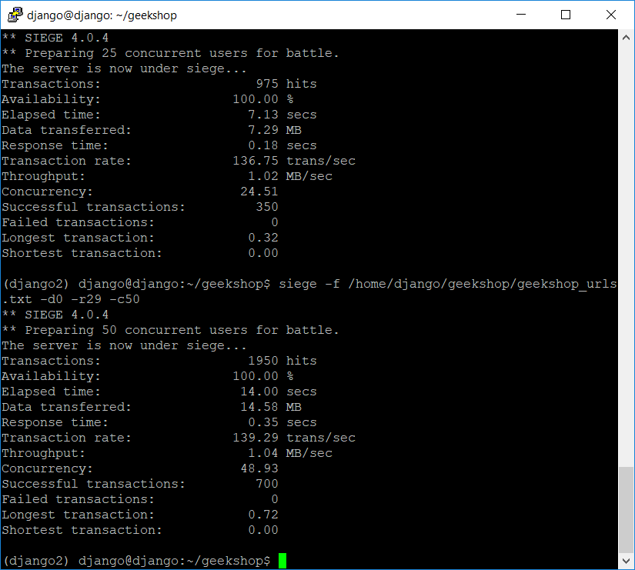 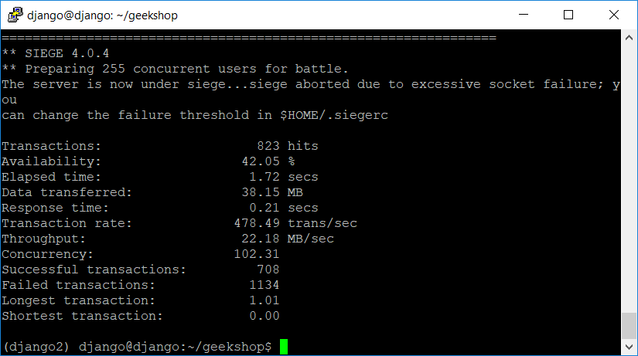

Было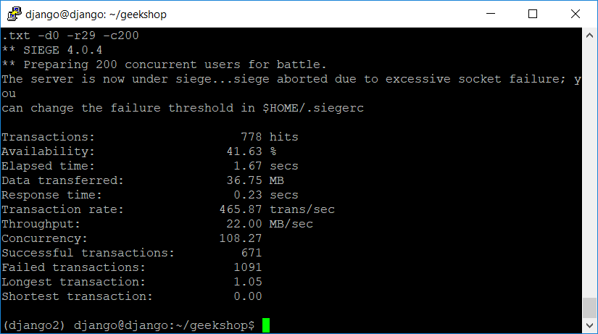

Стало

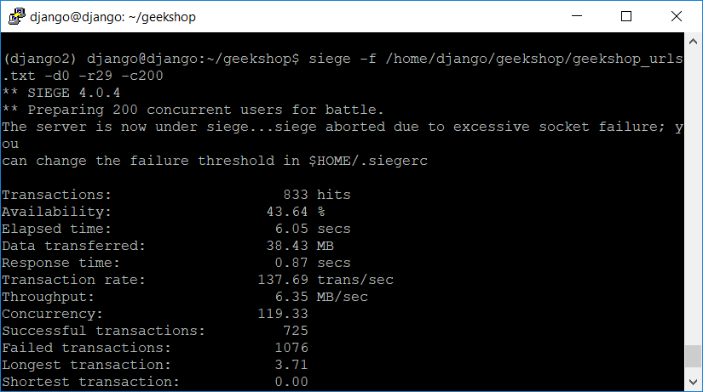

login as: django

django@192.168.1.33's password:

Welcome to Ubuntu 18.04.2 LTS (GNU/Linux 4.15.0-46-generic x86_64)

* Documentation: https://help.ubuntu.com

* Management: https://landscape.canonical.com

* Support: https://ubuntu.com/advantage

System information as of Tue Mar 19 17:01:54 UTC 2019

System load: 0.34 Processes: 103

Usage of /: 42.7% of 9.78GB Users logged in: 1

Memory usage: 27% IP address for enp0s3: 192.168.1.33

Swap usage: 0%

Могут быть обновлены 43 пакета.

19 обновлений касаются безопасности системы.

Last login: Tue Mar 19 17:00:24 2019

django@django:~$ cd geekshop

django@django:~/geekshop$ source dkango2/bin/activate

-bash: dkango2/bin/activate: No such file or directory

django@django:~/geekshop$ source django2/bin/activate

(django2) django@django:~/geekshop$ pip install django-debug-toolbar

Collecting django-debug-toolbar

Downloading https://files.pythonhosted.org/packages/01/9a/3db232bd15882d90d3c53de1f34ce0a522327849593c9198899713267cfe/django_debug_toolbar-1.11-py2.py3-none-any.whl (201kB)

100% |████████████████████████████████| 204kB 1.2MB/s

Requirement already satisfied: Django>=1.11 in ./django2/lib/python3.6/site-packages (from django-debug-toolbar)

Collecting sqlparse>=0.2.0 (from django-debug-toolbar)

Downloading https://files.pythonhosted.org/packages/ef/53/900f7d2a54557c6a37886585a91336520e5539e3ae2423ff1102daf4f3a7/sqlparse-0.3.0-py2.py3-none-any.whl

Requirement already satisfied: pytz in ./django2/lib/python3.6/site-packages (from Django>=1.11->django-debug-toolbar)

Installing collected packages: sqlparse, django-debug-toolbar

Successfully installed django-debug-toolbar-1.11 sqlparse-0.3.0

(django2) django@django:~/geekshop$ pip install django-debug-toolbar-template-profiler

Collecting django-debug-toolbar-template-profiler

Downloading https://files.pythonhosted.org/packages/f2/fe/59831f566c1c4be7642d570587c59ca8b14261b5ea0b84d13ee549297558/django-debug-toolbar-template-profiler-1.0.2.tar.gz

Requirement already satisfied: django-debug-toolbar>=1.0 in ./django2/lib/python3.6/site-packages (from django-debug-toolbar-template-profiler)

Requirement already satisfied: sqlparse>=0.2.0 in ./django2/lib/python3.6/site-packages (from django-debug-toolbar>=1.0->django-debug-toolbar-template-profiler)

Requirement already satisfied: Django>=1.11 in ./django2/lib/python3.6/site-packages (from django-debug-toolbar>=1.0->django-debug-toolbar-template-profiler)

Requirement already satisfied: pytz in ./django2/lib/python3.6/site-packages (from Django>=1.11->django-debug-toolbar>=1.0->django-debug-toolbar-template-profiler)

Building wheels for collected packages: django-debug-toolbar-template-profiler

Running setup.py bdist_wheel for django-debug-toolbar-template-profiler ... error

Complete output from command /home/django/geekshop/django2/bin/python3 -u -c "import setuptools, tokenize;__file__='/tmp/pip-build-2pz7x952/django-debug-toolbar-template-profiler/setup.py';f=getattr(tokenize, 'open', open)(__file__);code=f.read().replace('\r\n', '\n');f.close();exec(compile(code, __file__, 'exec'))" bdist_wheel -d /tmp/tmp1xeayxy6pip-wheel- --python-tag cp36:

usage: -c [global_opts] cmd1 [cmd1_opts] [cmd2 [cmd2_opts] ...]

or: -c --help [cmd1 cmd2 ...]

or: -c --help-commands

or: -c cmd --help

error: invalid command 'bdist_wheel'

----------------------------------------

Failed building wheel for django-debug-toolbar-template-profiler

Running setup.py clean for django-debug-toolbar-template-profiler

Failed to build django-debug-toolbar-template-profiler

Installing collected packages: django-debug-toolbar-template-profiler

Running setup.py install for django-debug-toolbar-template-profiler ... done

Successfully installed django-debug-toolbar-template-profiler-1.0.2

(django2) django@django:~/geekshop$ pip install wheel

Collecting wheel

Downloading https://files.pythonhosted.org/packages/96/ba/a4702cbb6a3a485239fbe9525443446203f00771af9ac000fa3ef2788201/wheel-0.33.1-py2.py3-none-any.whl

Installing collected packages: wheel

Successfully installed wheel-0.33.1

(django2) django@django:~/geekshop$ sudo systemctl status gunicorn

[sudo] password for django:

● gunicorn.service - gunicorn daemon

Loaded: loaded (/etc/systemd/system/gunicorn.service; enabled; vendor preset:

Active: active (running) since Tue 2019-03-19 16:59:59 UTC; 16min ago

Main PID: 758 (gunicorn)

Tasks: 4 (limit: 1111)

CGroup: /system.slice/gunicorn.service

├─758 /home/django/geekshop/django2/bin/python3 /home/django/geekshop

├─839 /home/django/geekshop/django2/bin/python3 /home/django/geekshop

├─842 /home/django/geekshop/django2/bin/python3 /home/django/geekshop

└─844 /home/django/geekshop/django2/bin/python3 /home/django/geekshop

мар 19 17:00:03 django gunicorn[758]: [2019-03-19 17:00:03 +0000] [844] [INFO] B

мар 19 17:02:13 django gunicorn[758]: context processor basket works

мар 19 17:02:13 django gunicorn[758]: - - [19/Mar/2019:20:02:13 +0300] "GET / H

мар 19 17:02:15 django gunicorn[758]: context processor basket works

мар 19 17:02:15 django gunicorn[758]: - - [19/Mar/2019:20:02:15 +0300] "GET /ca

мар 19 17:02:16 django gunicorn[758]: context processor basket works

мар 19 17:02:16 django gunicorn[758]: - - [19/Mar/2019:20:02:16 +0300] "GET /co

мар 19 17:02:20 django gunicorn[758]: - - [19/Mar/2019:20:02:20 +0300] "GET /ba

мар 19 17:02:21 django gunicorn[758]: context processor basket works

мар 19 17:02:21 django gunicorn[758]: - - [19/Mar/2019:20:02:21 +0300] "GET /au

lines 1-21/21 (END)

(django2) django@django:~/geekshop$ sudo systemctl restart gunicorn

(django2) django@django:~/geekshop$ python manage.py collectstatic

You have requested to collect static files at the destination

location as specified in your settings:

/home/django/geekshop/static

This will overwrite existing files!

Are you sure you want to do this?

Type 'yes' to continue, or 'no' to cancel: yes

133 static files copied to '/home/django/geekshop/static', 14 unmodified.

(django2) django@django:~/geekshop$ sudo systemctl restart gunicorn

(django2) django@django:~/geekshop$ sudo systemctl restart gunicorn

(django2) django@django:~/geekshop$

(django2) django@django:~/geekshop$ sudo apt install siege

[sudo] password for django:

Чтение списков пакетов… Готово

Построение дерева зависимостей

Чтение информации о состоянии… Готово

Следующие НОВЫЕ пакеты будут установлены:

siege

Обновлено 0 пакетов, установлено 1 новых пакетов, для удаления отмечено 0 пакетов, и 43 пакетов не обновлено.

Необходимо скачать 98,3 kB архивов.

После данной операции объём занятого дискового пространства возрастёт на 278 kB.

Пол:1 http://archive.ubuntu.com/ubuntu bionic/main amd64 siege amd64 4.0.4-1build1 [98,3 kB]

Получено 98,3 kB за 1с (101 kB/s)

Выбор ранее не выбранного пакета siege.

(Чтение базы данных … на данный момент установлено 68505 файлов и каталогов.)

Подготовка к распаковке …/siege_4.0.4-1build1_amd64.deb …

Распаковывается siege (4.0.4-1build1) …

Настраивается пакет siege (4.0.4-1build1) …

Обрабатываются триггеры для man-db (2.8.3-2ubuntu0.1) …

(django2) django@django:~/geekshop$ siege -f /home/django/geekshop/urls.txt -d1 -r29 -c1

New configuration template added to /home/django/.siege

Run siege -C to view the current settings in that file

[alert] unable to open file: /home/django/geekshop/urls.txt: No such file or directory

SIEGE 4.0.4

Usage: siege [options]

siege [options] URL

siege -g URL

Options:

-V, --version VERSION, prints the version number.

-h, --help HELP, prints this section.

-C, --config CONFIGURATION, show the current config.

-v, --verbose VERBOSE, prints notification to screen.

-q, --quiet QUIET turns verbose off and suppresses output.

-g, --get GET, pull down HTTP headers and display the

transaction. Great for application debugging.

-p, --print PRINT, like GET only it prints the entire page.

-c, --concurrent=NUM CONCURRENT users, default is 10

-r, --reps=NUM REPS, number of times to run the test.

-t, --time=NUMm TIMED testing where "m" is modifier S, M, or H

ex: --time=1H, one hour test.

-d, --delay=NUM Time DELAY, random delay before each requst

-b, --benchmark BENCHMARK: no delays between requests.

-i, --internet INTERNET user simulation, hits URLs randomly.

-f, --file=FILE FILE, select a specific URLS FILE.

-R, --rc=FILE RC, specify an siegerc file

-l, --log[=FILE] LOG to FILE. If FILE is not specified, the

default is used: /var/log/siege.log

-m, --mark="text" MARK, mark the log file with a string.

between .001 and NUM. (NOT COUNTED IN STATS)

-H, --header="text" Add a header to request (can be many)

-A, --user-agent="text" Sets User-Agent in request

-T, --content-type="text" Sets Content-Type in request

--no-parser NO PARSER, turn off the HTML page parser

--no-follow NO FOLLOW, do not follow HTTP redirects

Copyright (C) 2017 by Jeffrey Fulmer, et al.

This is free software; see the source for copying conditions.

There is NO warranty; not even for MERCHANTABILITY or FITNESS

FOR A PARTICULAR PURPOSE.

(django2) django@django:~/geekshop$ siege -f /home/django/geekshop/geekshop_urls.txt -d1 -r29 -c1

** SIEGE 4.0.4

** Preparing 1 concurrent users for battle.

The server is now under siege...

Transactions: 45 hits

Availability: 95.74 %

Elapsed time: 30.91 secs

Data transferred: 1.49 MB

Response time: 0.35 secs

Transaction rate: 1.46 trans/sec

Throughput: 0.05 MB/sec

Concurrency: 0.51

Successful transactions: 20

Failed transactions: 2

Longest transaction: 1.32

Shortest transaction: 0.00

(django2) django@django:~/geekshop$ sudo systemctl restart gunicorn

(django2) django@django:~/geekshop$ sudo systemctl restart gunicorn

(django2) django@django:~/geekshop$ sudo systemctl restart gunicorn

(django2) django@django:~/geekshop$ siege -f /home/django/geekshop/urls.txt -d1 -r29 -c1

[alert] unable to open file: /home/django/geekshop/urls.txt: No such file or directory

SIEGE 4.0.4

Usage: siege [options]

siege [options] URL

siege -g URL

Options:

-V, --version VERSION, prints the version number.

-h, --help HELP, prints this section.

-C, --config CONFIGURATION, show the current config.

-v, --verbose VERBOSE, prints notification to screen.

-q, --quiet QUIET turns verbose off and suppresses output.

-g, --get GET, pull down HTTP headers and display the

transaction. Great for application debugging.

-p, --print PRINT, like GET only it prints the entire page.

-c, --concurrent=NUM CONCURRENT users, default is 10

-r, --reps=NUM REPS, number of times to run the test.

-t, --time=NUMm TIMED testing where "m" is modifier S, M, or H

ex: --time=1H, one hour test.

-d, --delay=NUM Time DELAY, random delay before each requst

-b, --benchmark BENCHMARK: no delays between requests.

-i, --internet INTERNET user simulation, hits URLs randomly.

-f, --file=FILE FILE, select a specific URLS FILE.

-R, --rc=FILE RC, specify an siegerc file

-l, --log[=FILE] LOG to FILE. If FILE is not specified, the

default is used: /var/log/siege.log

-m, --mark="text" MARK, mark the log file with a string.

between .001 and NUM. (NOT COUNTED IN STATS)

-H, --header="text" Add a header to request (can be many)

-A, --user-agent="text" Sets User-Agent in request

-T, --content-type="text" Sets Content-Type in request

--no-parser NO PARSER, turn off the HTML page parser

--no-follow NO FOLLOW, do not follow HTTP redirects

Copyright (C) 2017 by Jeffrey Fulmer, et al.

This is free software; see the source for copying conditions.

There is NO warranty; not even for MERCHANTABILITY or FITNESS

FOR A PARTICULAR PURPOSE.

(django2) django@django:~/geekshop$ siege -f /home/django/geekshop/geekshop_urls.txt -d1 -r29 -c1

** SIEGE 4.0.4

** Preparing 1 concurrent users for battle.

The server is now under siege...

Transactions: 39 hits

Availability: 100.00 %

Elapsed time: 15.35 secs

Data transferred: 0.29 MB

Response time: 0.01 secs

Transaction rate: 2.54 trans/sec

Throughput: 0.02 MB/sec

Concurrency: 0.02

Successful transactions: 14

Failed transactions: 0

Longest transaction: 0.03

Shortest transaction: 0.00

(django2) django@django:~/geekshop$ siege -f /home/django/geekshop/geekshop_urls.txt -d0 -r29 -c25

** SIEGE 4.0.4

** Preparing 25 concurrent users for battle.

The server is now under siege...

Transactions: 975 hits

Availability: 100.00 %

Elapsed time: 7.13 secs

Data transferred: 7.29 MB

Response time: 0.18 secs

Transaction rate: 136.75 trans/sec

Throughput: 1.02 MB/sec

Concurrency: 24.51

Successful transactions: 350

Failed transactions: 0

Longest transaction: 0.32

Shortest transaction: 0.00

(django2) django@django:~/geekshop$ siege -f /home/django/geekshop/geekshop_urls.txt -d0 -r29 -c50

** SIEGE 4.0.4

** Preparing 50 concurrent users for battle.

The server is now under siege...

Transactions: 1950 hits

Availability: 100.00 %

Elapsed time: 14.00 secs

Data transferred: 14.58 MB

Response time: 0.35 secs

Transaction rate: 139.29 trans/sec

Throughput: 1.04 MB/sec

Concurrency: 48.93

Successful transactions: 700

Failed transactions: 0

Longest transaction: 0.72

Shortest transaction: 0.00

(django2) django@django:~/geekshop$ siege -f /home/django/geekshop/geekshop_urls.txt -d0 -r29 -c1000

================================================================

WARNING: The number of users is capped at 255. To increase this

limit, search your .siegerc file for 'limit' and change

its value. Make sure you read the instructions there...

================================================================

** SIEGE 4.0.4

** Preparing 255 concurrent users for battle.

The server is now under siege...siege aborted due to excessive socket failure; you

can change the failure threshold in $HOME/.siegerc

Transactions: 823 hits

Availability: 42.05 %

Elapsed time: 1.72 secs

Data transferred: 38.15 MB

Response time: 0.21 secs

Transaction rate: 478.49 trans/sec

Throughput: 22.18 MB/sec

Concurrency: 102.31

Successful transactions: 708

Failed transactions: 1134

Longest transaction: 1.01

Shortest transaction: 0.00

(django2) django@django:~/geekshop$ siege -f /home/django/geekshop/geekshop_urls.txt -d0 -r29 -c500

================================================================

WARNING: The number of users is capped at 255. To increase this

limit, search your .siegerc file for 'limit' and change

its value. Make sure you read the instructions there...

================================================================

** SIEGE 4.0.4

** Preparing 255 concurrent users for battle.

The server is now under siege...siege aborted due to excessive socket failure; you

can change the failure threshold in $HOME/.siegerc

Transactions: 854 hits

Availability: 42.94 %

Elapsed time: 1.89 secs

Data transferred: 38.70 MB

Response time: 0.23 secs

Transaction rate: 451.85 trans/sec

Throughput: 20.48 MB/sec

Concurrency: 105.20

Successful transactions: 718

Failed transactions: 1135

Longest transaction: 1.03

Shortest transaction: 0.00

(django2) django@django:~/geekshop$ siege -f /home/django/geekshop/geekshop_urls.txt -d0 -r29 -c200

** SIEGE 4.0.4

** Preparing 200 concurrent users for battle.

The server is now under siege...siege aborted due to excessive socket failure; you

can change the failure threshold in $HOME/.siegerc

Transactions: 778 hits

Availability: 41.63 %

Elapsed time: 1.67 secs

Data transferred: 36.75 MB

Response time: 0.23 secs

Transaction rate: 465.87 trans/sec

Throughput: 22.00 MB/sec

Concurrency: 108.27

Successful transactions: 671

Failed transactions: 1091

Longest transaction: 1.05

Shortest transaction: 0.00

(django2) django@django:~/geekshop$